Manual Book

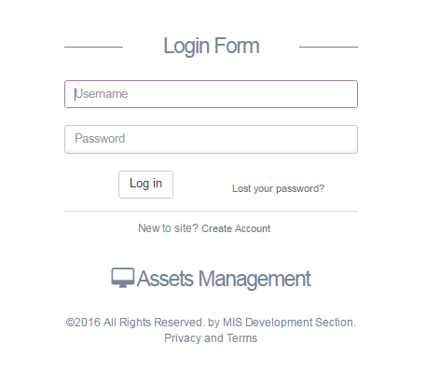

Asset Management System
2017
MIS Development System

General Description
This manual explain functions to support employees use systems that will help to manage assets.
Be sure to read this manual before using Asset Management System.
Platform Requirement
Asset Management system can run on platforms:
- Windows XP, 7, 8 and 10.
- Google Chrome
- Internet Explorer 11
Features and Main Menu
- System Features
  - User Role
An access level designates the operation authority given to a user who log into the system.
The access level is classified into the following four levels, in order from the highest level where all of operations are allowed.
1. Superadmin
2. Accounting
3. Approver
4. Admin/Operator.
This interface for login into the system.
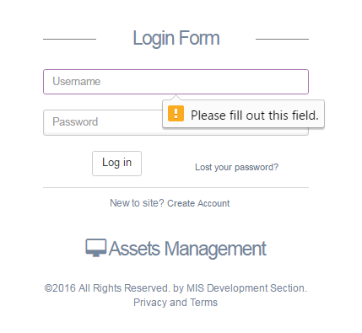

Figure 1 Login Form
When opening system n log into system a username and password are Required. After inputting them login certification is performed based on the set user registration information. The available operations determined by the user’s access level can be performed after login.
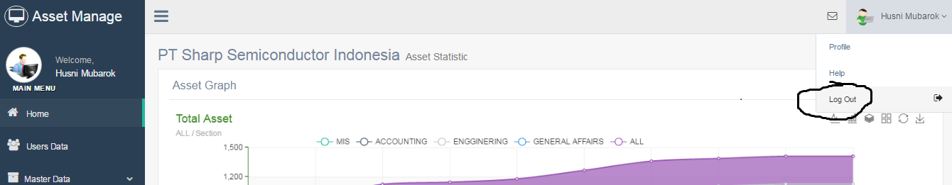
For log out from the system, user can press his name at top right corner system and then pick logout.

Figure 2 Logout button

  - Pop up Detail
This feature is easier for users to manage data and view the data. Some of the processes that use this feature are:
- Form input and Edit data
To simplify and accelerate the user to manipulate the data, the system uses pop-up display for form input and edit.

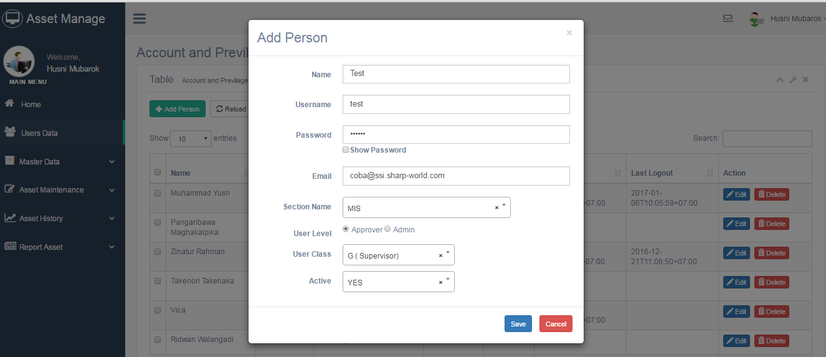
Figure 3 Pop up add and Edit data

- Detail Information

In addition to data manipulation, pop up display is also used to view detailed data.

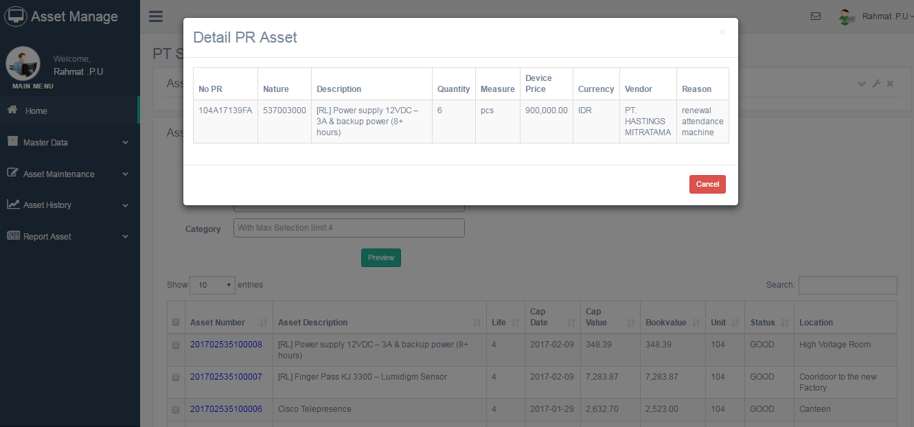
Figure 4 Pop up for detail information

  - Select Box and Multiple Select Box
This feature, enables the user to fill input fields with auto complete and selection. Typing the word and will show the option and the user can select.

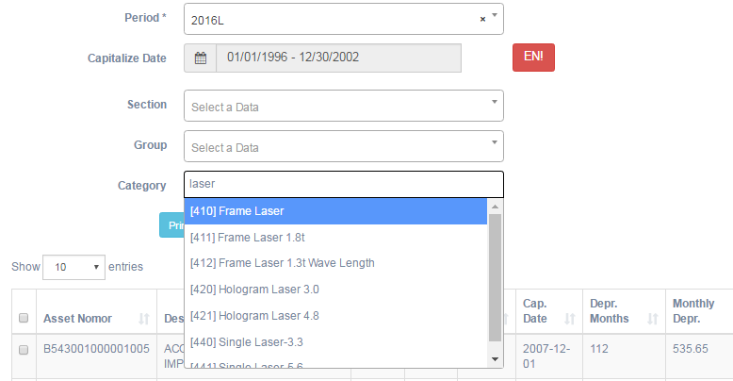
Figure 5 Select Field for add a data

  - DataTable
DataTable is a feature for grid view data. In the DataTable are sorting and search functions. Look this figure.
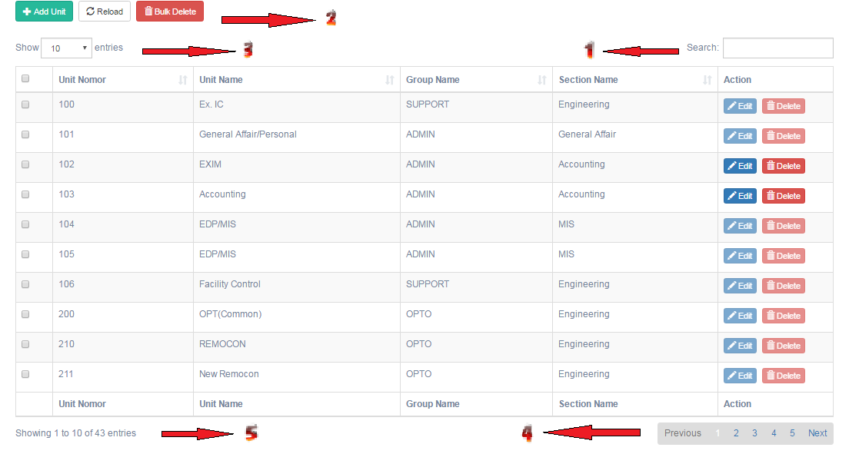
Figure 6 DataTable

1. Search Box
Used to search for data in the table.
2. Function Button
- Bulk Delete
Used to delete some data, tick the box on the left of the table and then presh button bulk delete so that the selected data will be deleted.
- Reload
This button is used to load the data in the table.
- Add
Button to display the page that will be used to add data. Just click button and popup page will appear.
3. Filter data
Filter box is used to display many of its existing data in the table.
4. Pagination Bar
A line that is used to display data in accordance with the page table.
5. Line information data
Line to show the total data that is displayed and the overall data.

  - Graph and Diagram
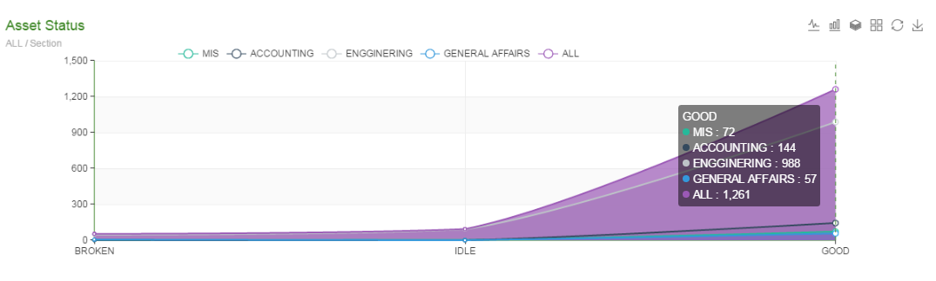

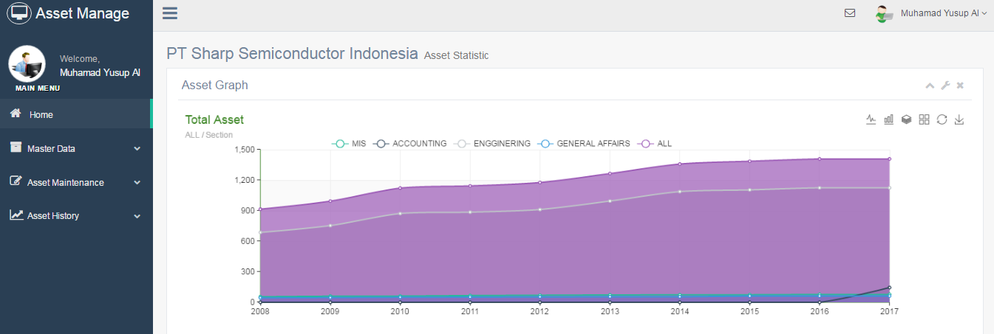
Figure 7Status Diagram
Figure 8 Total Asset Diagram

To change display of the graphic, click on the line that is on the top right of the graphic and to know the data please hover graphic.

- Master Data

- Master Unit
1. Go to Menu Master Data - > Unit Data.
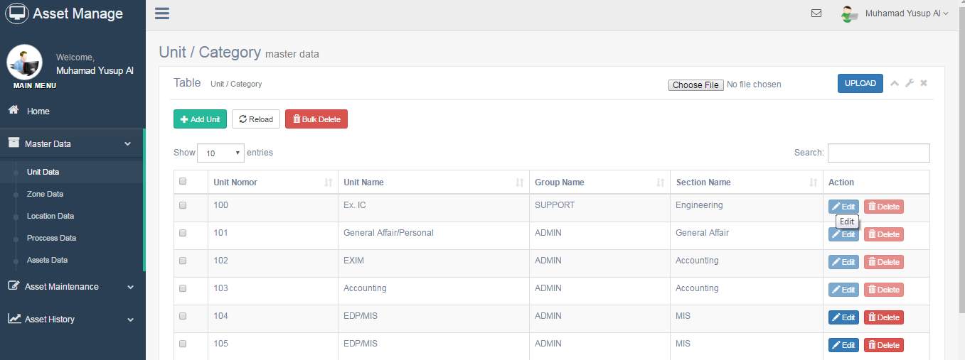
Figure 9 Master Unit Page

- Adding Data
- Click the Add Unit button.
- Appears pages to add data unit.
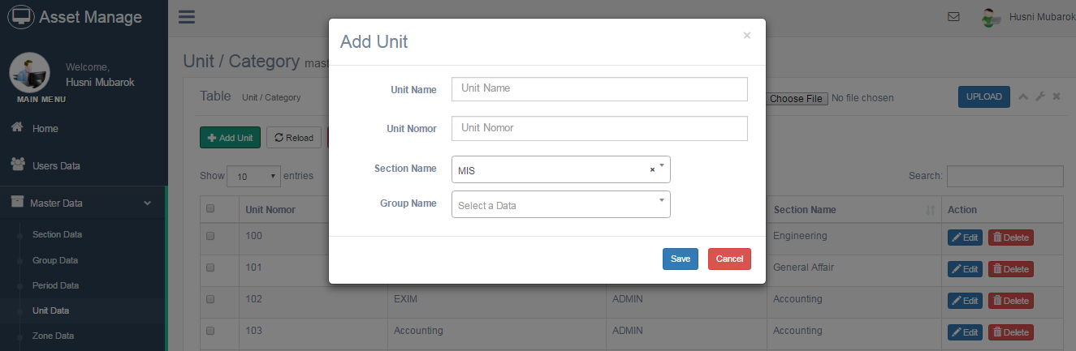
Figure 10 Add Unit

- Fill the page with the appropriate data. (Marked with * are required).
- Click Save to add data or Cancel to dismiss popup windows.

- Editing Data
- Click the Edit button.
- Appears pages to Edit data unit.
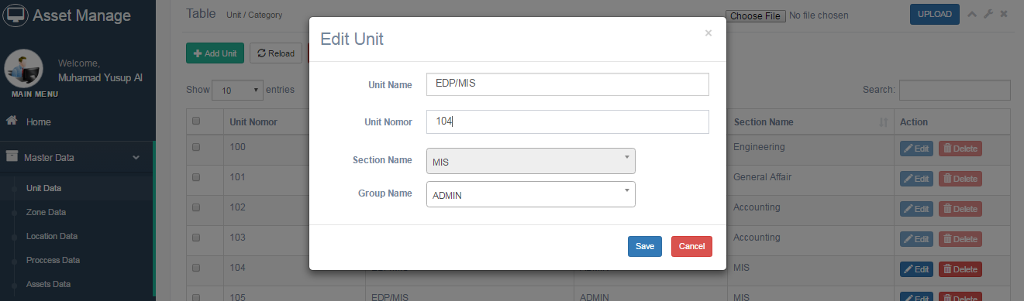
Figure 11 Edit Unit

- Fill the page with the appropriate data. (Marked with * are required).
- Click Save to add data or Cancel to dismiss popup windows.

- Deleting Data
- Click the Delete button.
- Appears alert to delete data.

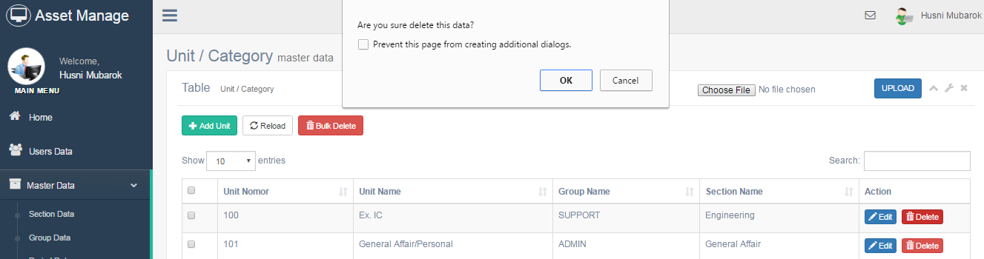
Figure 12 delete alert

- Click Oke to delete data or Cancel to dismiss popup alert.

- Master Zone
1. Go to Menu Master Data - > Zone Data
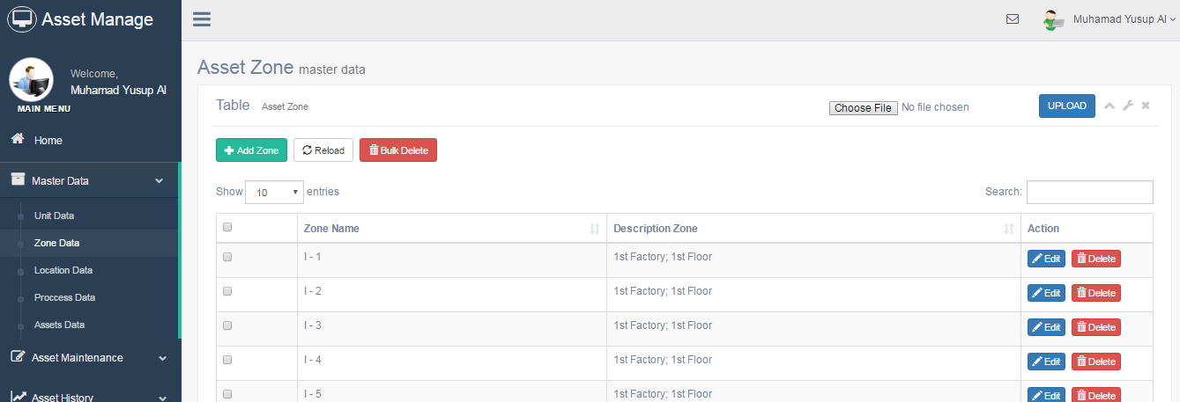
Figure 13Data Zone

- Adding Data
- Click the Add Zone button.
- Appears pages to add data zone.
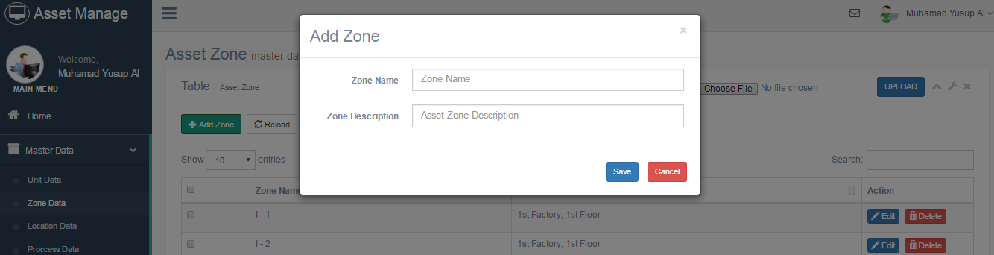
Figure 14 Add Zone

- Fill the page with the appropriate data. (Marked with * are required).
- Click Save to add data or Cancel to dismiss popup windows.
- Editing Data
- Click the Edit button.
- Appears pages to Edit data zone.
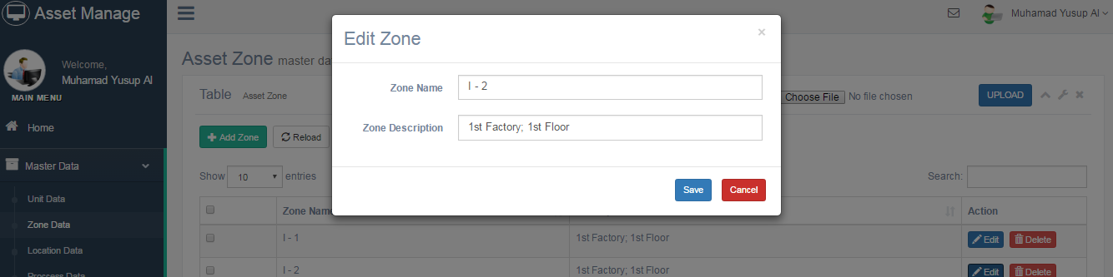
Figure 15 Edit Zone

- Fill the page with the appropriate data. (Marked with * are required).
- Click Save to add data or Cancel to dismiss popup windows.

- Deleting Data
- Click the Delete button.
- Appears alert to delete data.
- Click Oke to delete data or Cancel to dismiss popup alert.

- Master Location
1. Go to Menu Master Data - > Location Data.
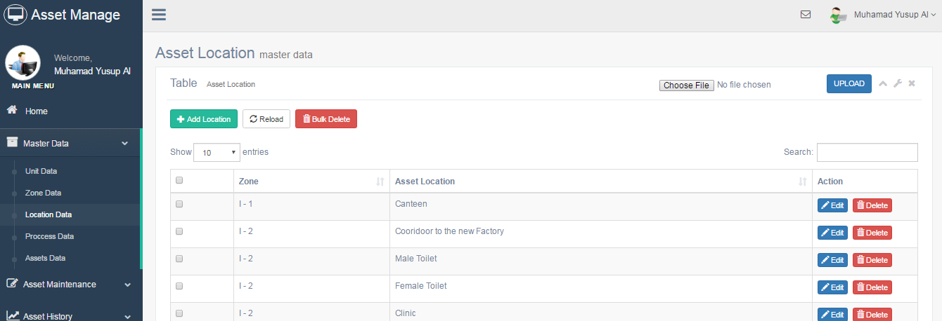
Figure 16 Master Location

- Adding Data
- Click the Add Location Button.
- Appears pages to add data location.
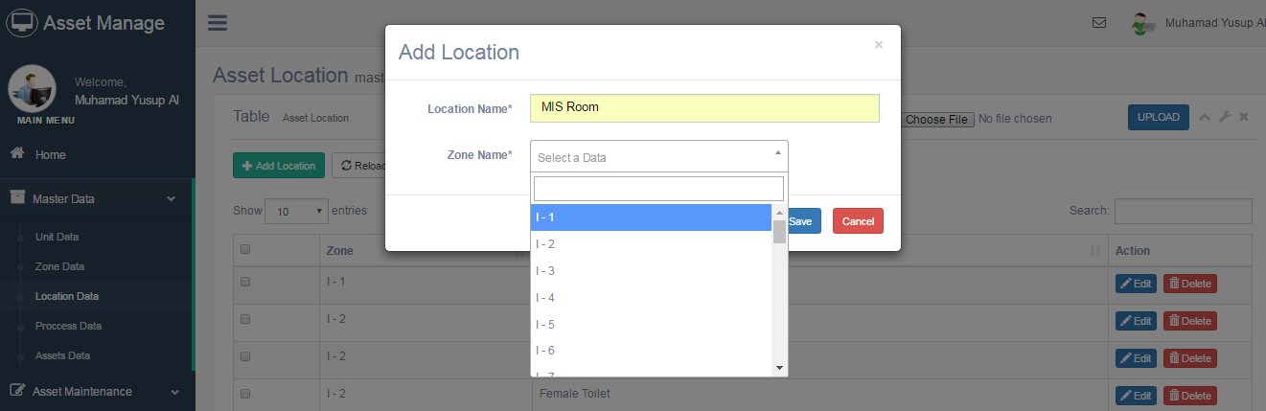
Figure 17 Add Location

- Fill the page with the appropriate data. (Marked with * are required).
- Click Save to add data or Cancel to dismiss popup windows.
- Editing Data
- Click the Edit button.
- Appears pages to Edit data location.
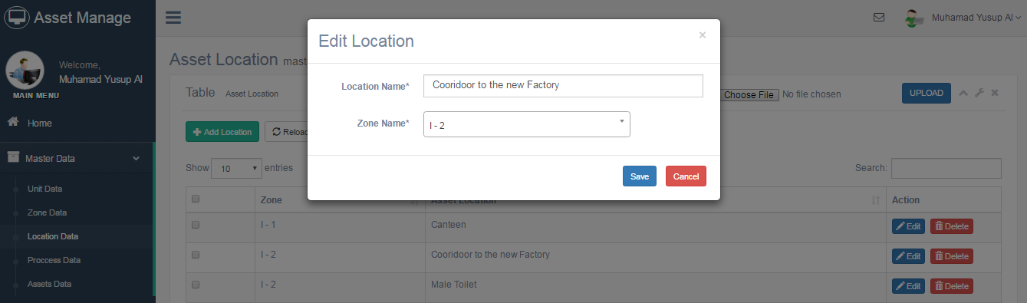

Figure 18 Edit Data

- Fill the page with the appropriate data. (Marked with * are required).
- Click Save to add data or Cancel to dismiss popup windows.

- Deleting Data
- Click the Delete button.
- Appears alert to delete data.
- Click Oke to delete data or Cancel to dismiss popup alert.

- Master Process
1. Go to Menu Master Data - > Process Data.

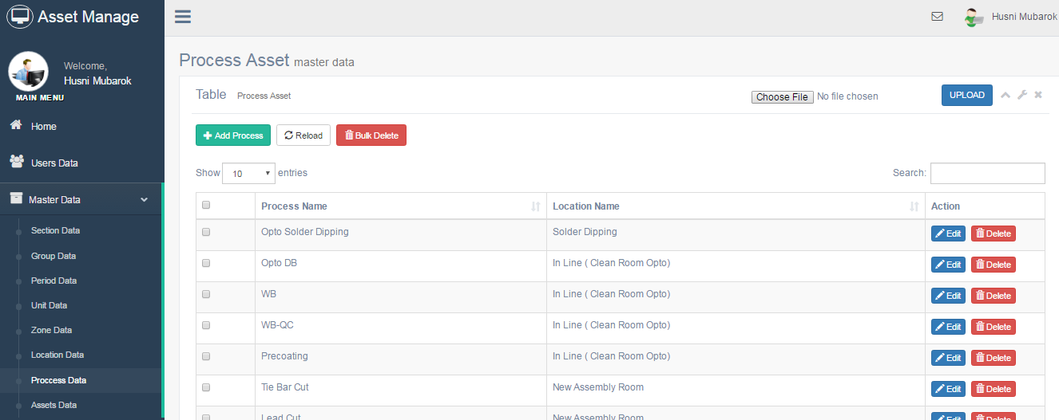
Figure 19 Process Master

\

- Adding Data
- Click the Add Process button.
- Appears pages to add data process.

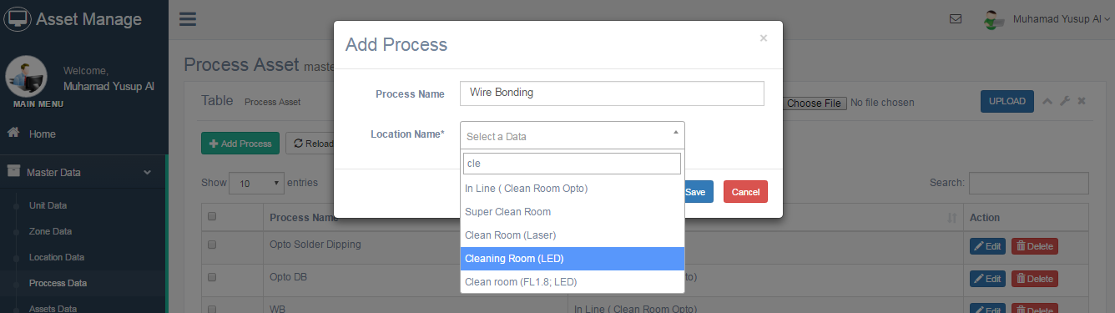
Figure 20 add Process

- Fill the page with the appropriate data. (Marked with * are required).
- Click Save to add data or Cancel to dismiss popup windows.

- Editing Data
- Click the Edit button.
- Appears pages to Edit data process.

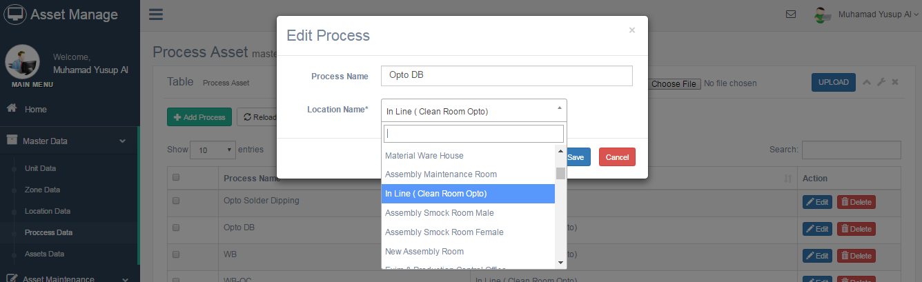

Figure 21 Edit Process

- Fill the page with the appropriate data. (Marked with * are required).
- Click Save to add data or Cancel to dismiss popup windows.

- Deleting Data
- Click the Delete button.
- Appears alert to delete data.
- Click Oke to delete data or Cancel to dismiss popup alert.

- Master Asset
1. Go to Menu Master Data - > Assets Data.

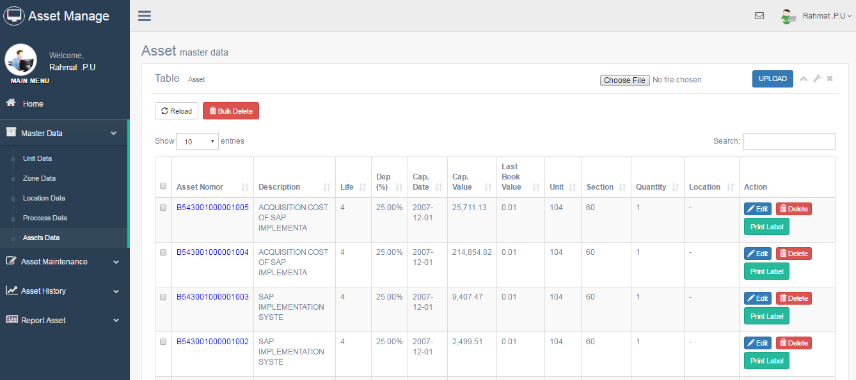
Figure 22 Master Asset

- Editing Data
- Click the Edit button.
- Appears pages to Edit data Asset.

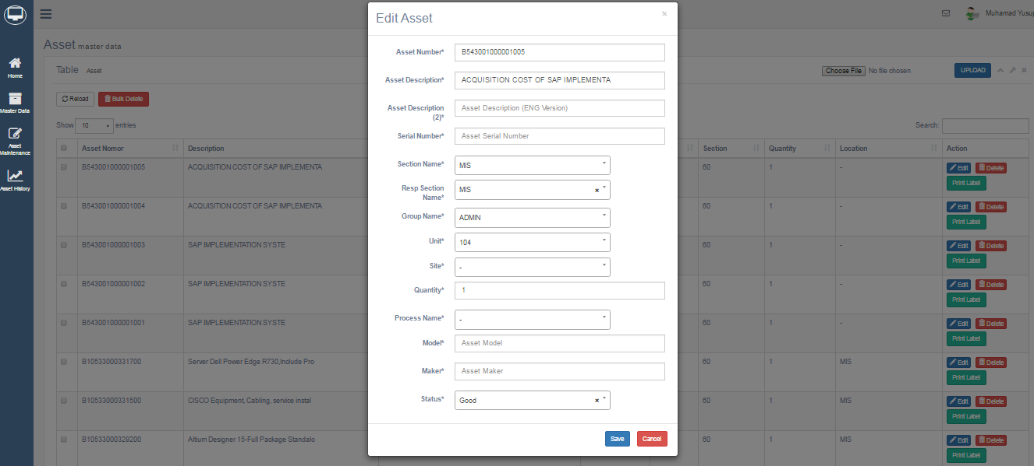
Figure 23 Edit Asset

- Fill the page with the appropriate data. (Marked with * are required).
- Click Save to add data or Cancel to dismiss popup windows.

- Deleting Data
- Click the Delete button.
- Appears alert to delete data.
- Click Oke to delete data or Cancel to dismiss popup alert.

- Detail Asset
- Click the blue number asset on the table
- Appears popup to view detail asset.
Figure 24 Detail asset
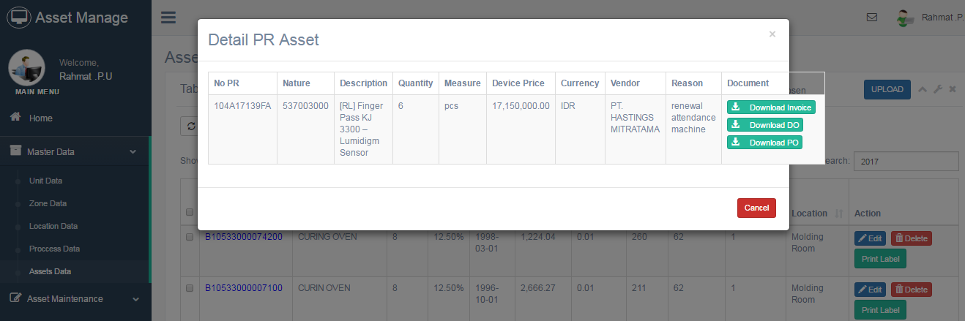

- Click the download button to download Invoice, DO, and PO Asset.
- Print Label Asset
- Click the Print Label button.
- Appear the page to see the number of assets.
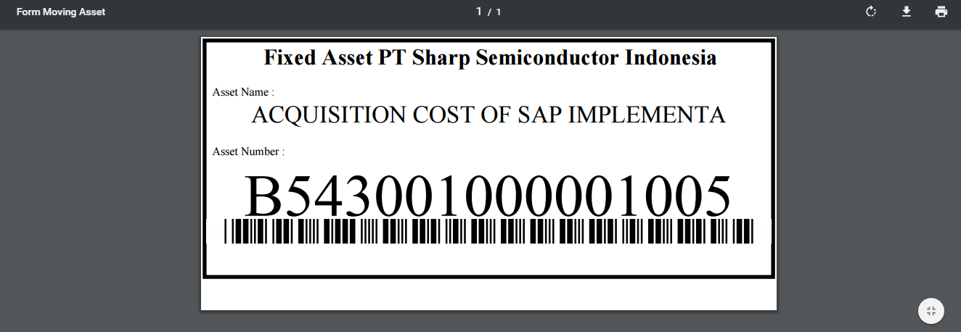
Figure 25 Label Asset

- Click Print.

- Asset Registration
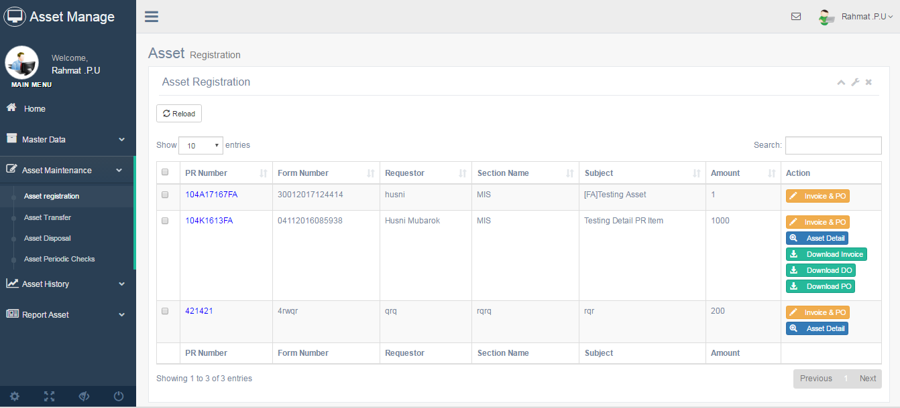
Figure 26 Registrasi Asset

- Go to Menu Asset maintenance -> Register asset.
- Click button Invoice & PO.
- Appear popup to upload document PO , DO and Invoice.
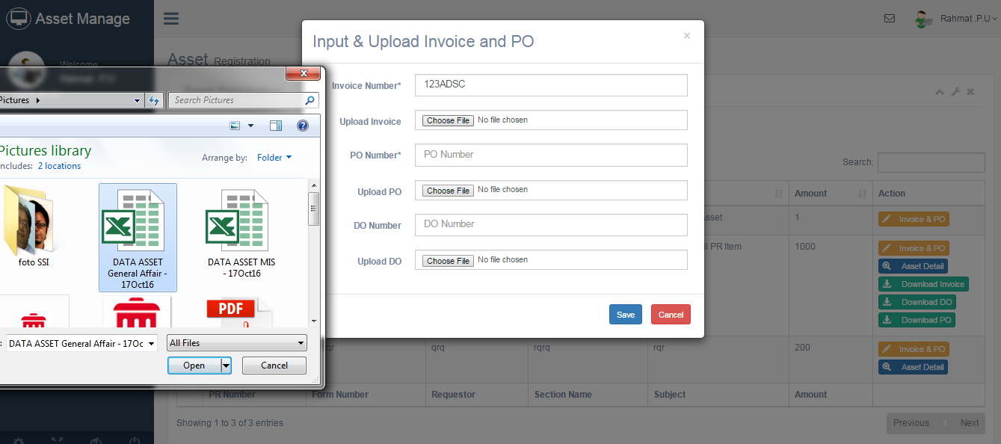

Figure 27 Input & upload PO, DO and Invoice

- Fill field and click choose file to pick document from your directory.
- Click save to process upload and cancel to dismiss popup windows.
- After upload Invoice then appear button asset detail to input detail asset.

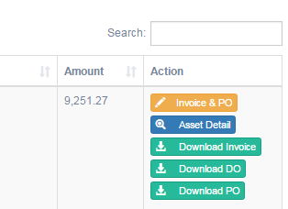
Figure 28 Button Asset detail

- Click Asset detail button.
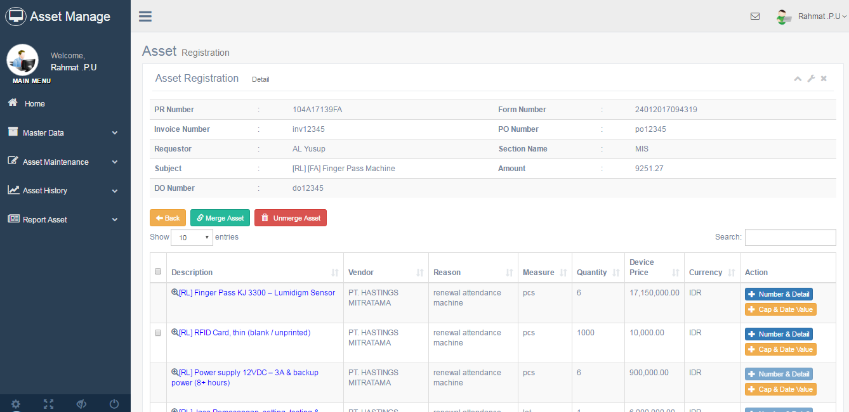
Figure 29 Detail Asset Page

- You have 2 option for register asset
- Merge Asset and Unmerge
- Checklist box on the right side table.
- Click Button Merge Asset.

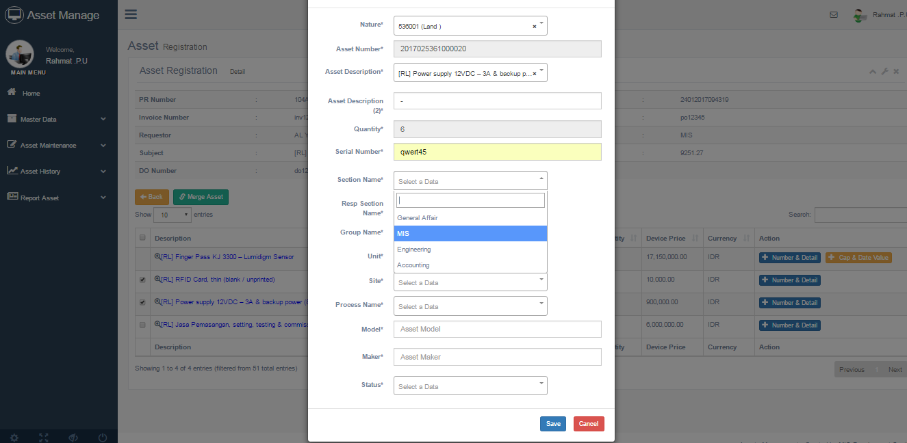
Figure 30 Form Merge Asset

- Fill the form with the appropriate data. (Marked with * are required).
- Click Save to process input or Cancel to dismiss popup window.
- Appear Unmerge Asset Button.
- Click Unmerge Asset Button.
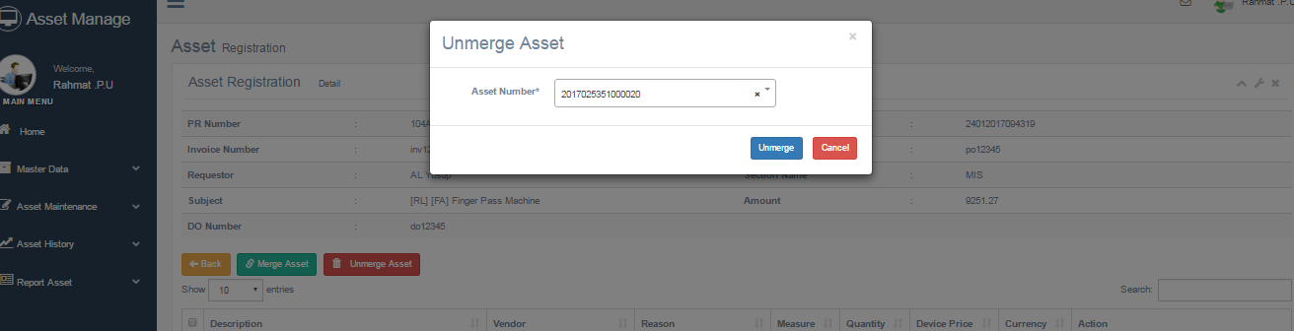
Figure 31 Unmerge Form

- Select Number Asset.
- Click Unmerge Button to process or Cancel to dismiss popup windows.

- Stand-alone Asset.
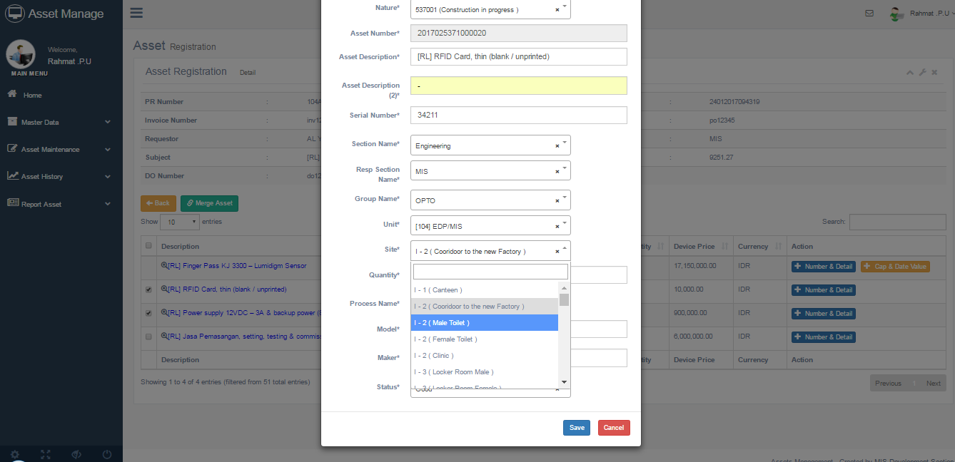
- Click Number & detail button on the table.

Figure 32 Form for Stand-alone Asset

- Fill the form with the appropriate data. (Marked with * are required).
- Click Save to process input or Cancel to dismiss popup windows.

- After register number asset, will be appear Cap & Date value button.
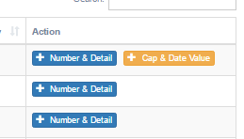
Figure 33 Button Cap $ Date Value

- Click button cap & date value for input capitalize date and value also for start depreciation.
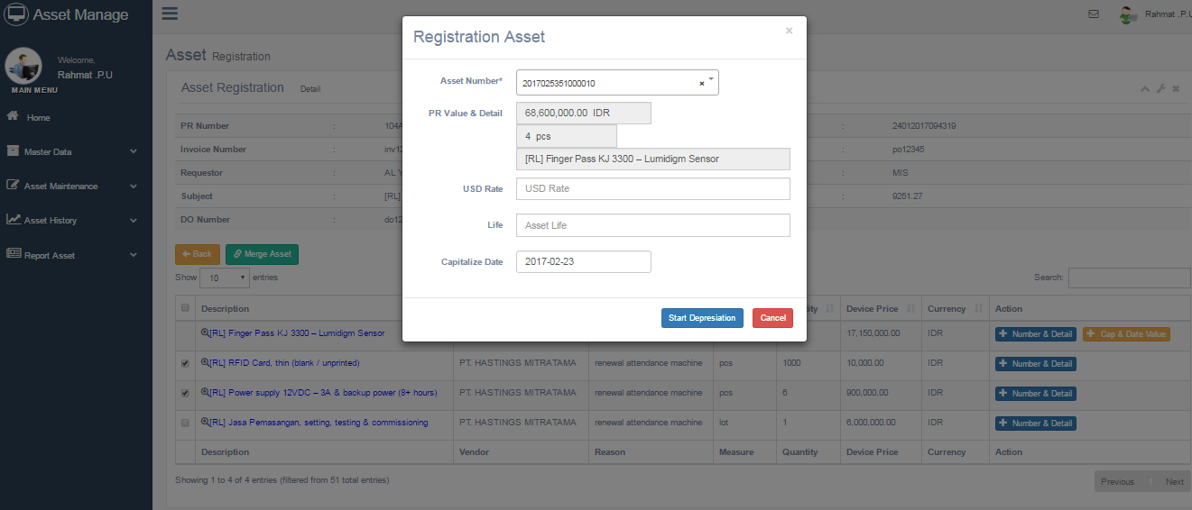
Figure 34 Form start depreciation

- Click Start depreciation to finish process or Cancel to dismiss windows popup.

- Transfer of Asset
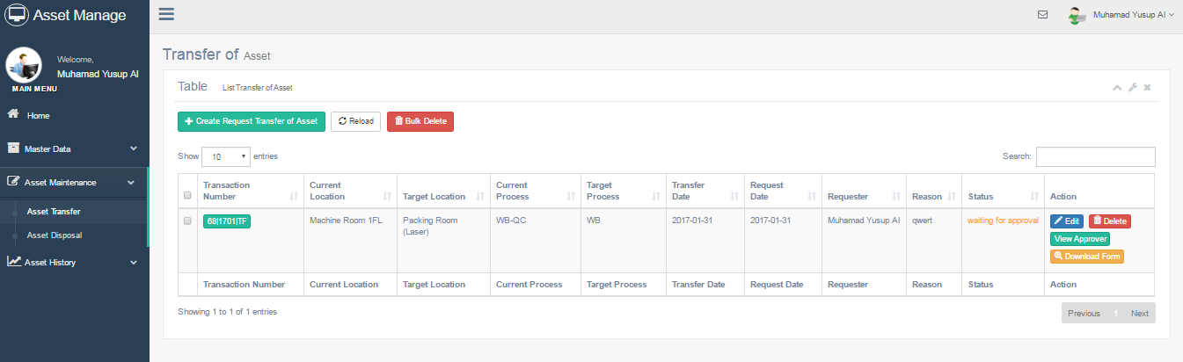
Figure 35 List transfer Asset

- Go to Menu Asset maintenance -> Transfer asset.
- Click Create Request Transfer of Asset button.
- Appear the Transfer Form page.
- Click Fill Asset List button.

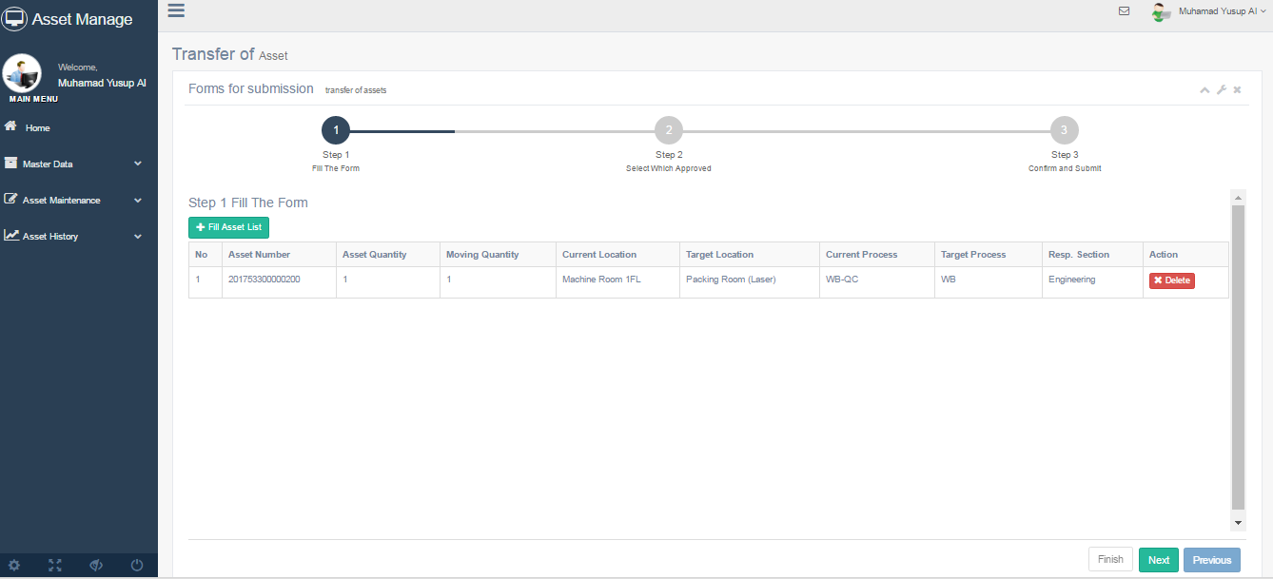
Figure 36 Step 1 Fill The Form

- In the Step 1 Click Fill asset list button.

- Fill the form with the appropriate data. (Marked with * are required).
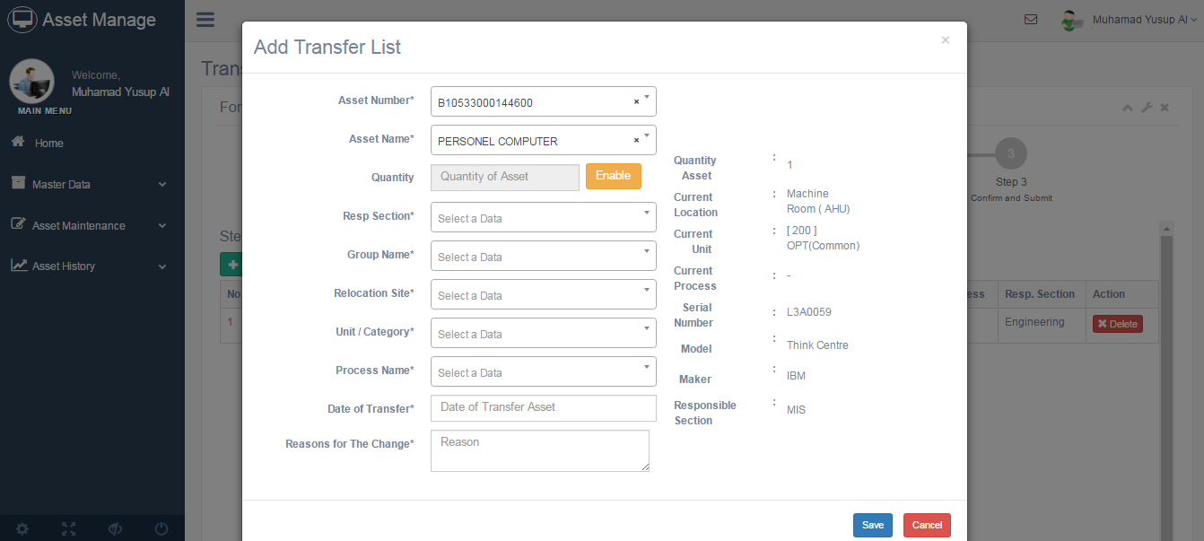
Figure 37 Form Input Transfer List

- Click Save to Process or Cancel to dismiss popup window.
- Click Next button.
- In the Step 2(Select approver).

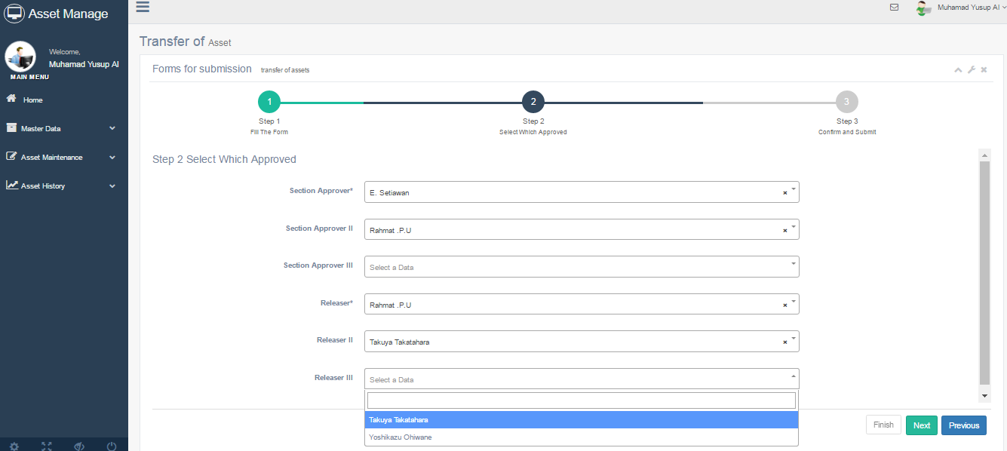
Figure 38 Form Approver for transfer asset

- Select approver in accordance with the position.
- Click Next button.
- In the Step 3(Email).
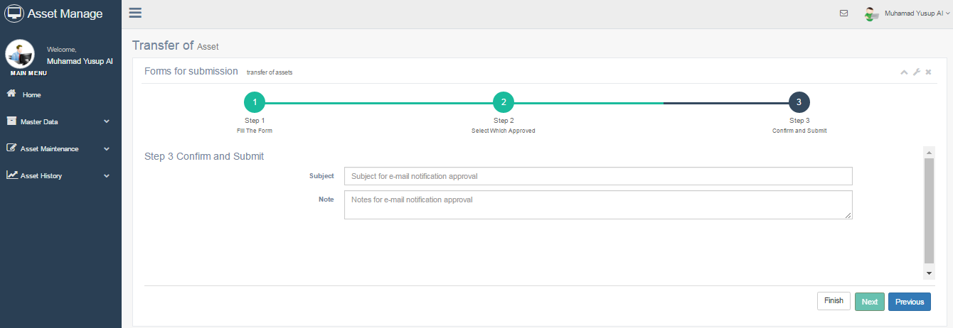
Figure 39 Form Subject and description email

- Fill the form with the appropriate data. (Marked with * are required).
- Click Finish button to process.

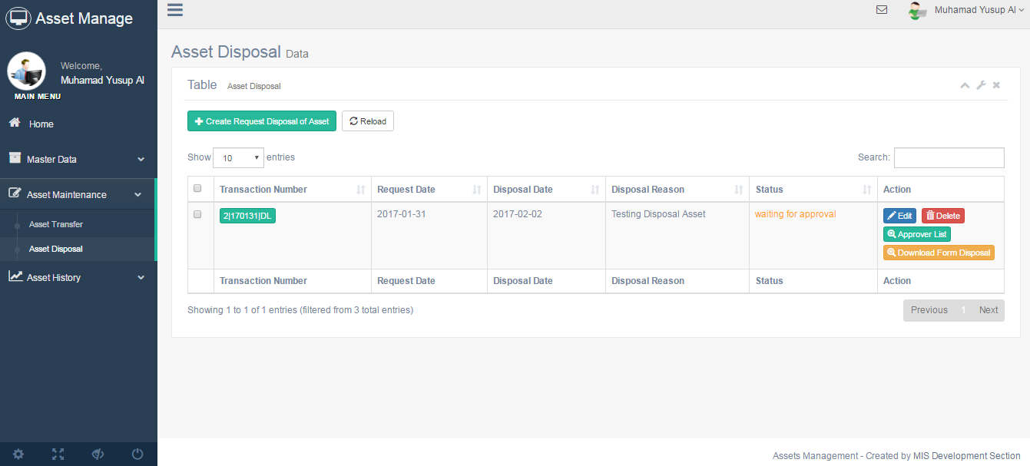
- Disposal of Asset
Figure 40 List Disposal Asset

- Go to Menu Asset maintenance -> Disposal Asset.
- Click Create Request Disposal of Asset button.
- Appear page for disposal asset.
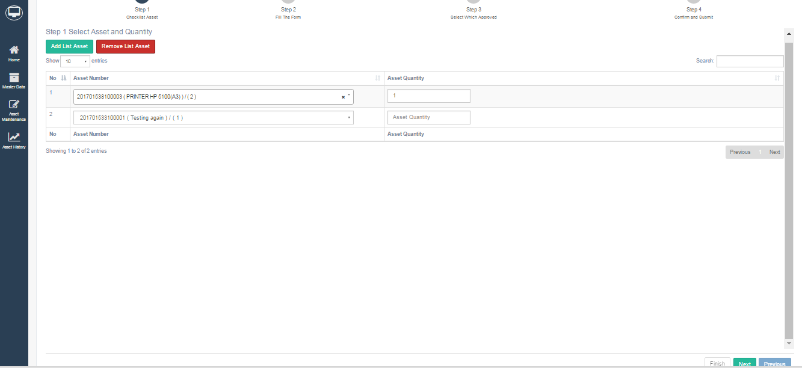
Figure 41 Step 1 Disposal asset

- In the Step 1(checklist asset) click Add List Asset button to add maximal input asset and click Remove List Asset button to decrease maximal input asset.
- Fill the form with the appropriate data. (Marked with * are required).
- Click Next button.
- In the Step 2(Fill The Form). Fill the form with the appropriate data. (Marked with * are required).
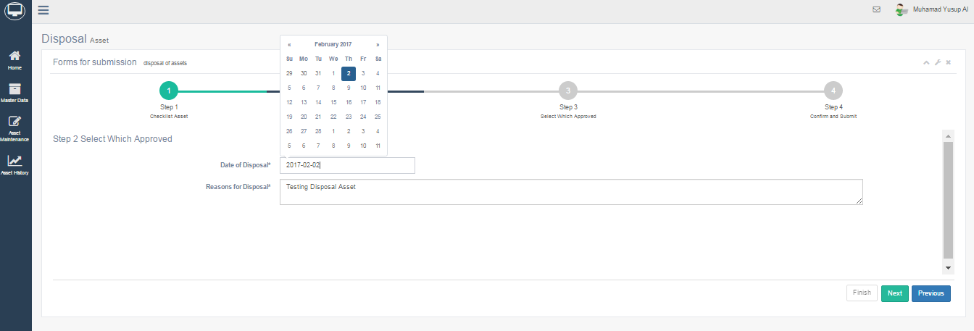
Figure 42 Step 2 Fill the form disposal

- Click Next Button.
- In the Step 3(Select Approver).

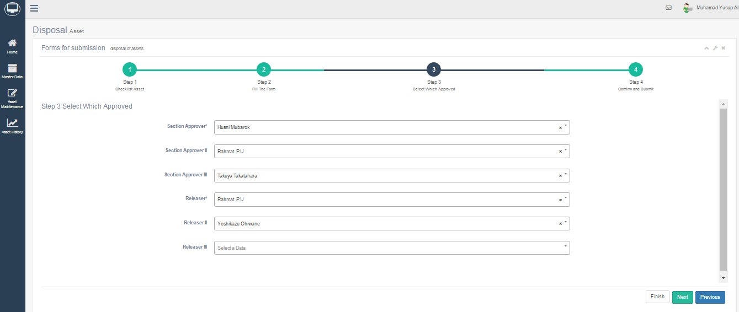
Figure 43 Step 3 Disposal asset ( Select Approver)

- Select approver in accordance with the position.
- Click Next Button.

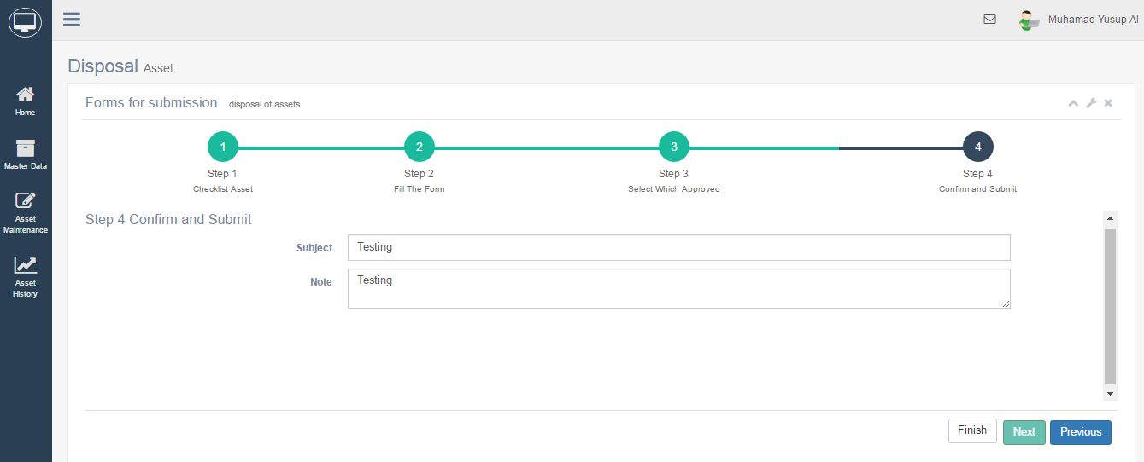
- In the Step 4(Email).
Figure 44 Step 4 disposal asset (Email)

- Fill the form with the appropriate data. (Marked with * are required).
- Click Finish button to process.

- Print Periodical Check Sheet

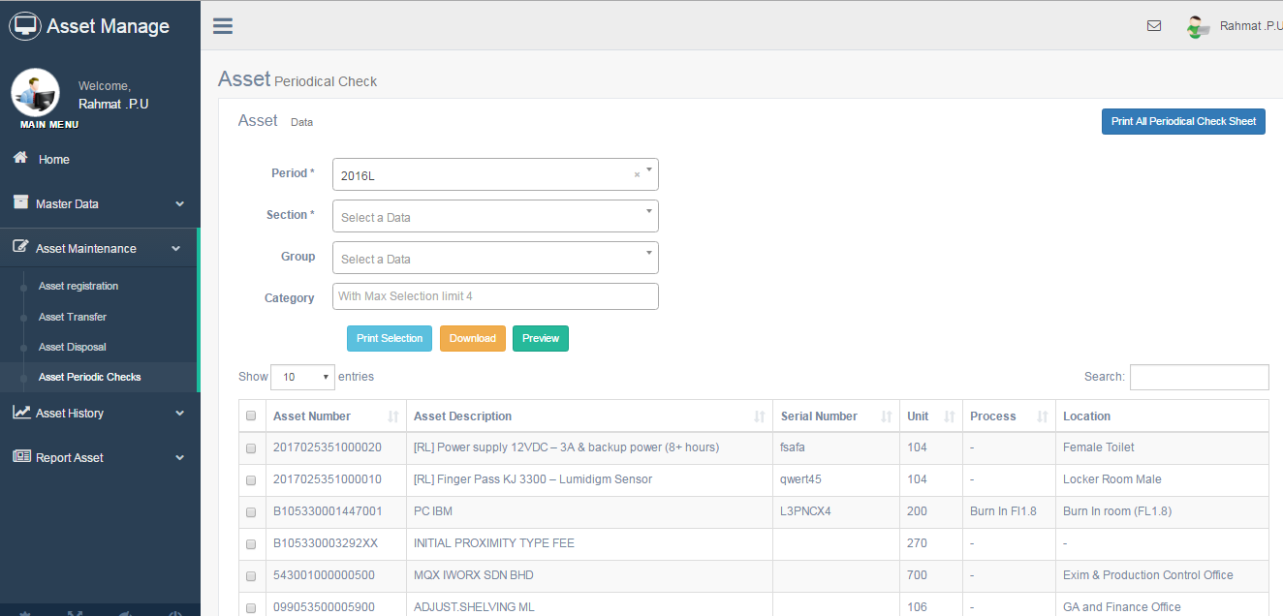
Figure 45 Periodical check sheet table

- Click Print All Periodical Check Sheet button.
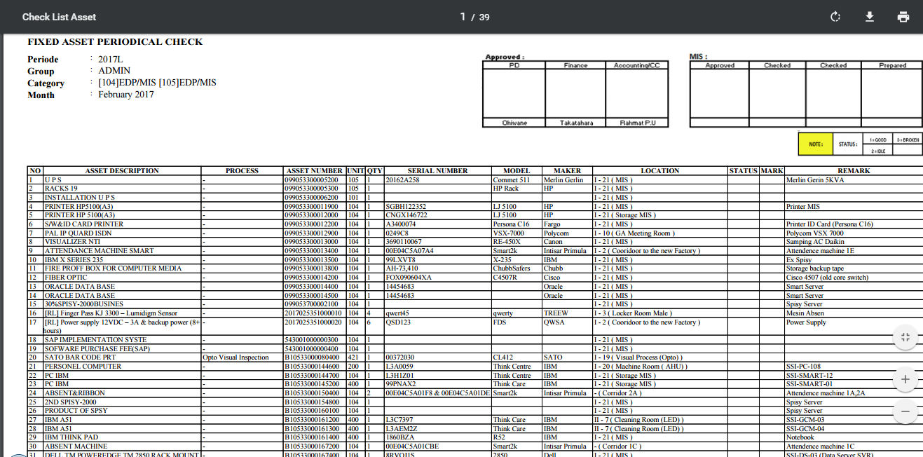
Figure 46 List check sheet

- Click Print button to print and Download for save list check sheet to your directory.

- Approve and Reject Transfer & Disposal asset.

- Go to Menu Asset Maintenance -> Asset transfer for transfer asset and go to Menu Asset Maintenance -> Asset disposal for disposal asset..
- Click Approve button to approve transaction.
- Click Decline button to reject transaction.

- Print & Preview Report Asset

- Report SL Asset
- Go to Menu Report Asset -> SL Asset Rteport
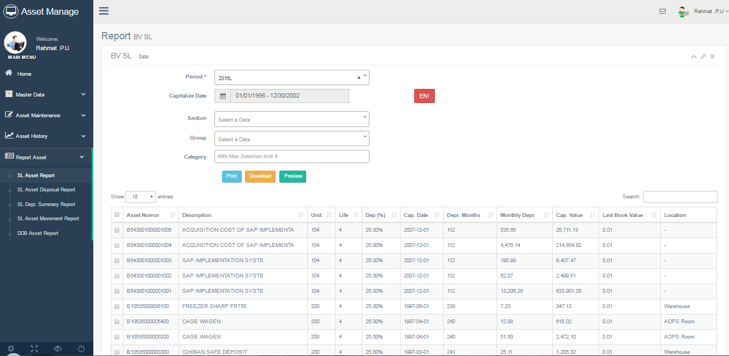
Figure 47 SL Asset Report

- Click Print Button to Print the Selected Report and press Ctrl + P.
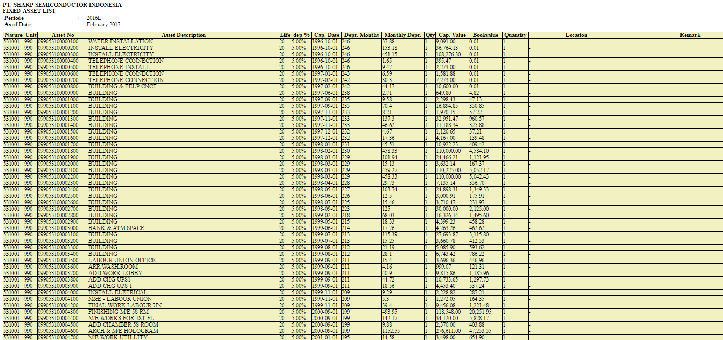
Figure 48 list for SL asset

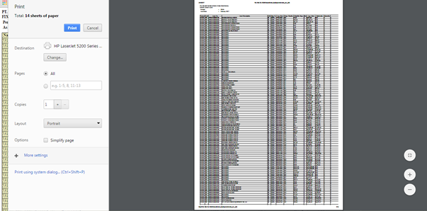
Figure 49 interface print list asset (Ctrl + P)

- Click Download button to download the selected Report.
- Click Preview button to view list asset on the table.

- Report Disposal Asset
- Go to Menu Report Asset -> SL Asset Disposal Report.
- Click Print Button to Print the Selected Report.
- Click Download button to download the selected Report.
- Click Preview button to view list asset on the table.

- Report SL Depreciation Summary
- Go to Menu Report Asset -> SL Depr. Summary Report
- Click Download button to download the selected Report.

- Report SL Movement Asset
- Go to Menu Report Asset -> SL Asset Movement Report
- Click Download button to download the selected Report.

- Report DDB Asset
- Go to Menu Report Asset -> DDB Asset Report
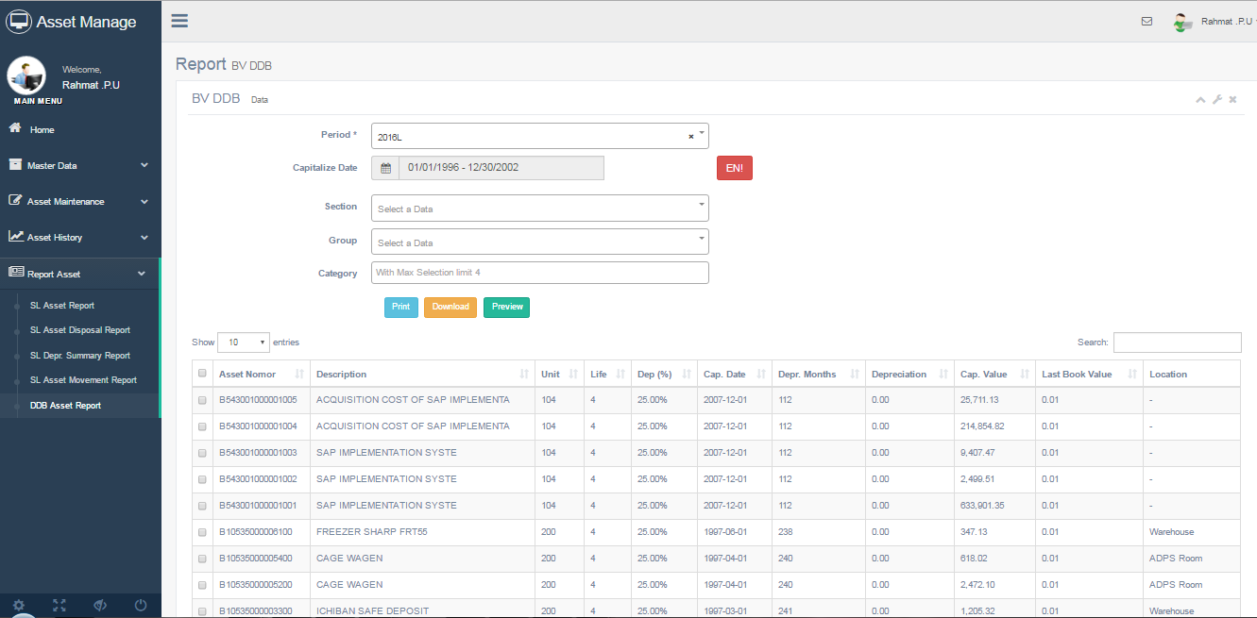
Figure 50 Interface for DDB Asset Page

- Click Print Button to Print the Selected Report and press Ctrl + P.
- Click Download button to download the selected Report.
- Click Preview button to view list asset on the table.

